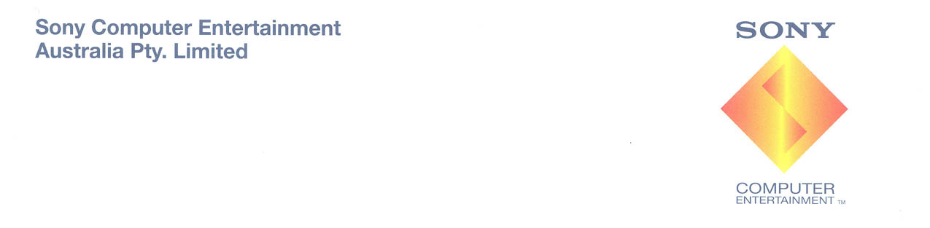

AFL PREMIERSHIP 2005™ - GAME OVERVIEW

Introduction
AFL Premiership 2005 – The official game of the AFL Premiership™ will launch across Australia on September 8, 2005 and features an exciting new mix of features and in-game options. The game has been developed by Melbourne based IR Gurus in consultation with the AFL administration and a close-knit group of current and former players, coaches and umpires. AFL Premiership 2005 will be available on PlayStation®2 and is an Official AFL product.

Developers
Directed by Andrew Niere from IR Gurus in Melbourne and developed over a two year period, the 23 man development team assembled included a good mix of experience and youth. The team resolved not to re-use anything from any previous versions of the game with the aim of making dramatic improvements in terms of gameplay and graphical quality.

“The new members of our team were able to provide fresh eyes and enthusiasm for the subject matter which played an important role in the quality of the finished product,” said Andrew Niere.

He continued, “the art team included a lot of really experienced and talented artists from other high profile projects, such as Heroes of the Pacific and Transformers. They did a great job building a detailed library of stadium and other in game assets which are a feature of the game.”

Overview
AFL Premiership 2005 gives players three main game options including single game, season mode and online mode. A single game involves a quick match between any two teams while season mode is home to the full AFL simulation, including a draft and pre-season competition, home and away rounds, a finals series as well as player trading and an AFL Tribunal. Online mode is a new feature of the game that allows up to four players to battle over the Internet.

The AFL Tribunal functions have been taken straight from the 2005 AFL season using the new demerit points system which was adopted by the AFL this year. In addition, weather can be set to wet or dry and in a wet match, everything is more difficult, with marks less successful, kicks travelling less distance and player speeds being reduced.

The game was developed in partnership with the game’s governing body and is designed to provide a more realistic experience of AFL. The development team poured over hours of match day commentary to develop a comprehensive library of dialogue to be recorded by Denis Cometti, Dermott Breretton and Christi Malthouse, while stadiums and players were recreated from visual references, photos and videos to ensure they were accurately recreated. Lastly, the crowd and ground sound effects from AFL Premiership 2005 were drawn from a library of actual match day sounds that had been recorded over the last 10 years.

“The game is an Official AFL product however this was not just about putting a licensing logo onto the game. We wanted to ensure that the game capitalised on the knowledge and resources of the AFL administration with the aim of developing a product that fans will recognise as ‘quintessentially’ AFL,” Niere said.

Gameplay
Groups of game players were consulted for their feedback on the control set while motion capture suits were used on AFL players to recreate player movements and the free flowing nature of an AFL game. The final control set is intuitive with similar actions mapped to the same key. Further, the use of motion capture suits allowed the development team to get a sense of ‘football smarts’ into the bots so their on field actions reflect those of their real life counterparts.

Lastly, AFL Premiership 2005 allows players to interact with three main camera angles – a ‘low-end’ camera, a ‘high-end’ camera and a standard ‘side’ camera. The low-end camera takes players right into the action, the high-end camera allows players to look the long way down the ground while the side camera is similar to that used on other sports simulation titles. Journalists, local gamers and AFL players were consulted in finalising these in game options.
- ends -

For further information, please contact:

Richard Baker at Weber Shandwick in Sydney
02 9994 4463 or ribaker@webershandwick.com

Dominic Hilton-Foster at Weber Shandwick in Sydney
02 9994 4453 or dhilton-foster@webershandwick.com

For further information / product images please visit http://www.scee.presscentre.com/au

Developer: IR Gurus
Genre: AFL
No. of Players: 1 – 4 and online
Platform: PlayStation®2
Peripherals: Analog Controller (DUALSHOCK®2), Memory Card (8MB) (for PlayStation®2), Network Adaptor (Ethernet) (for PlayStation®2),
Release Date: 8 September 2005

About Sony Computer Entertainment Europe Ltd.
Sony Computer Entertainment Europe (SCEE), based in London, is responsible for the distribution, marketing and sales of PS one®, PlayStation®2 and PlayStation® Portable software and hardware in 104 territories across Europe, the Middle East, Africa and Oceania. SCEE also develops, publishes, markets and distributes games software for the three formats, and manages the third party licensing programs for these platforms in the PAL territories. At the end of June 2005, over 40 million PlayStation® units had been shipped across these PAL territories, over 102 million worldwide. Between its European debut on 24 November 2000 and 20th July 2005, over 33 million PlayStation®2 units have been shipped across the PAL territories, over 91 million world-wide, making it one of the most successful consumer electronic products in history. Between the launch of the PSP in Japan in December 2005 and 21 July 2005, over 5 million PSPs have been shipped worldwide.
PlayStation and the PlayStation logo, PS one and PS2 are registered trademarks of Sony Computer Entertainment Inc. PSP and UMD (Universal Media Disc) are trademarks of Sony Computer Entertainment Inc. All other trademarks are property of their respective owners.

About Sony Computer Entertainment Australia
Sony Computer Entertainment Australia (SCE Aust.) is responsible for the distribution, marketing, sales and network support of PS one®, PlayStation®2 and PlayStation Portable® software and hardware in Australia and New Zealand. Sony Computer Entertainment commenced trading in Australia in 1995. At the end of July 2005, over 2.2 million units of PlayStation®2 consoles had been shipped across Australia and New Zealand.

PlayStation and the PlayStation logo, PS one and PS2 are registered trademarks of Sony Computer Entertainment Inc. All other trademarks are property of their respective owners.

More information about PlayStation products can be found at http://www.scee.com and www.au.playstation.com or visit the Virtual Press Office at www.scee.presscentre.com/au.

